SEMICONDUCTOR ELECTRONICS

INTRODUCTION AND OVERVIEW OF SEMICONDUCTORS

Group 14 Elements Classification:
- Group 14 elements include Carbon (C), Silicon (Si), and Germanium (Ge), all having four valence electrons in their outermost shell.

Reason for Excluding Carbon:
- Carbon has a very small atomic size, resulting in exceptionally strong covalent bond strength. Because the bonds are so strong, it is extremely difficult to break them and liberate electrons for conduction at room temperature, making Carbon behave as an insulator rather than a semiconductor.

Reason for Using Silicon and Germanium:
- Silicon and Germanium have larger atomic sizes compared to Carbon, resulting in weaker covalent bond strengths. Covalent bonds in Silicon and Germanium can be broken by supplying thermal energy or electromagnetic radiation, liberating electrons for conduction.

CLASSIFICATION OF MATERIALS BASED ON ELECTRICAL CONDUCTION

Conductors:
- Conductors possess a very large number of free electrons (electron sea model). They exhibit high electrical conductivity and low electrical resistivity. Examples include Gold(Au), Silver(Ag), and Copper(Cu).
Insulators:
- Insulators do not contain free electrons for electrical conduction. They exhibit extremely low electrical conductivity.
Semiconductors:
- At room temperature, semiconductors have very few free electrons and behave essentially as insulators. However, when their temperature is raised, covalent bonds break and conduction becomes possible.

ENERGY BAND THEORY OF SOLIDS
Discrete Energy Levels in Isolated Atoms:
- In an isolated atom, electrons revolve in well-defined shells (such as n = 1, 2, 3) and possess sharp, discrete energy levels as described by Bohr's atomic model (E = -13.6 Z² / n² eV).

Band Formation in Solid Lattice:
- When atoms come close together to form a solid crystal lattice, interatomic forces and electrostatic interactions between neighboring nuclei and electrons cause energy levels to fluctuate and spread into continuous ranges or bands of allowed energies.
Inner Shells vs Valence Shell:
- Inner shell electron energy levels remain intact and unaffected by neighboring atoms. Only the outermost valence shell electron energies spread out into energy bands due to interatomic bonding interactions.

Valence Band (VB):
- The lower energy band containing bound valence electrons that participate in covalent bonding within the lattice.
Conduction Band (CB):
- The higher energy band representing free electrons that have been liberated from covalent bonds. An electron present in the Conduction Band represents a free electron capable of conduction.
Band Gap Energy (ΔE_g) or Forbidden Gap:
- The energy difference between the bottom of the Conduction Band (E_C) and the top of the Valence Band (E_V): ΔE_g = E_C - E_V. No electron can occupy an energy state within this forbidden energy gap.
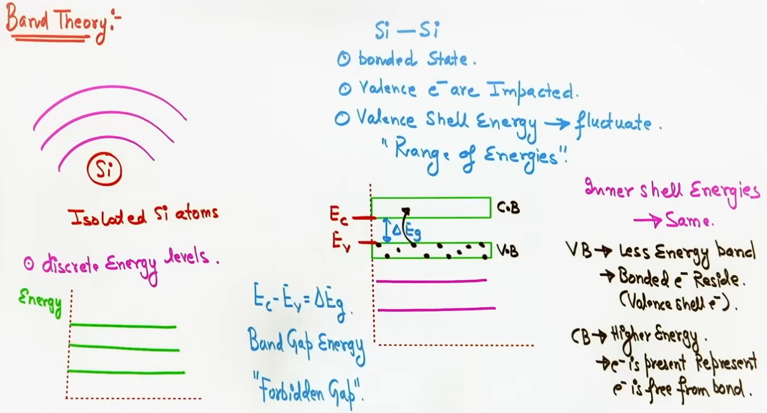
CLASSIFICATION OF MATERIALS BASED ON ENERGY BAND THEORY
Conductors:
- The Valence Band and Conduction Band overlap, resulting in zero band gap energy (ΔE_g = 0). Valence electrons simultaneously act as conduction electrons without requiring external excitation energy.
Insulators:
- The Conduction Band and Valence Band are separated by a large energy band gap (ΔE_g ≥ 3 eV).
- Lattice Breakdown Limitation: Supplying energy equal to ΔE_g (≥ 3 eV) causes the crystal lattice to breakdown or melt before valence electrons can jump into the Conduction Band, because the band gap energy exceeds the lattice energy.
Semiconductors:
- The Conduction Band and Valence Band are separated by a small energy band gap (ΔE_g ≈ 1 eV).
- Band Gap Values: Silicon has ΔE_g ≈ 1.1 eV, while Germanium has ΔE_g ≈ 0.7 eV.
- Because ΔE_g is smaller than the lattice breakdown energy, thermal energy can break covalent bonds and promote electrons to the Conduction Band without destroying the lattice.
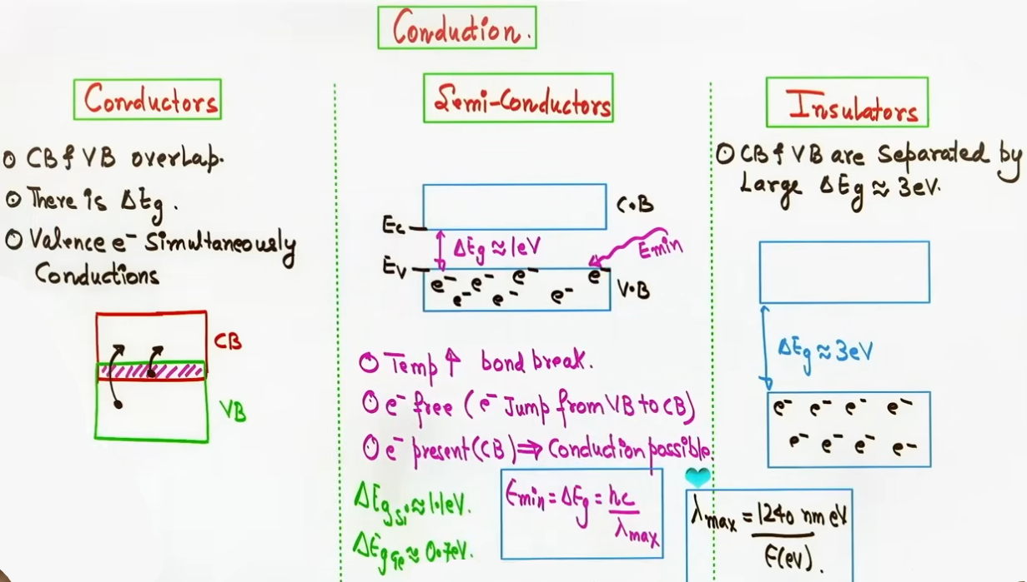
CONCEPT OF HOLES AND CHARGE CARRIERS

Crystal Structure:
- In a pure Silicon or Germanium crystal, each atom forms four covalent bonds with four neighboring atoms.
Room Temperature Behavior:
- At 0 K or room temperature, all valence electrons are bound in covalent bonds, leaving no free electrons. Thus, pure semiconductors act as insulators at low temperatures.
Creation of Holes:
- When thermal energy breaks a covalent bond, an electron escapes into the Conduction Band, leaving a vacant site in the Valence Band termed a hole.
Hole Transport Mechanism:
- Holes are missing electron sites in the Valence Band.
- When an electric field is applied, bound electrons in adjacent covalent bonds hop into the vacant hole site. As adjacent electrons step into the vacant site sequentially, the hole appears to move in the direction of the electric field.
Physical Properties of Holes:
1. A hole is not a real physical positive particle; it is a vacant electron site that acts as a virtual positive charge carrier (+e).
2. Hole transport occurs in the Valence Band through the hopping of bound electrons.
3. Free electron transport occurs in the Conduction Band independently.
4. The "effective mass" of a hole is greater than that of a free electron because hopping of bound electrons is hindered by potential barriers between atoms.
5. Hole mobility (μ_h) is strictly lower than free electron mobility (μ_e).
Total Current in Semiconductors:
- Unlike conductors (where current is due to free electrons only) or electrolytes (where current is due to positive and negative ions), the total current in a semiconductor is the sum of free electron current (I_e) in the Conduction Band and hole current (I_h) in the Valence Band: I = I_e + I_h.
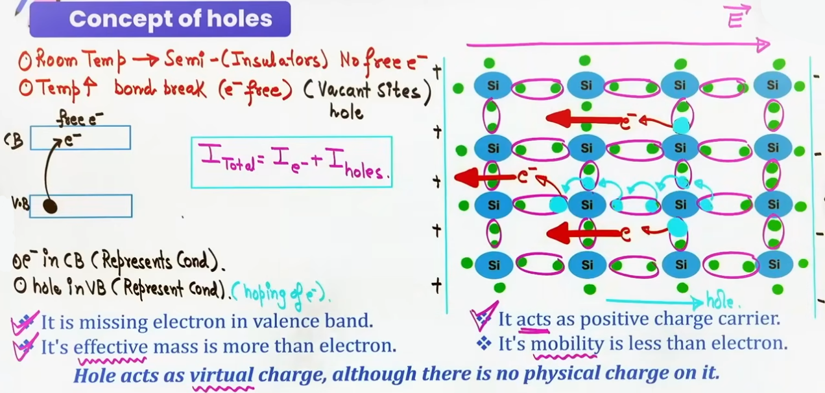
INTUITION AND CONCEPTUAL UNDERSTANDING

- Musical Chairs Analogy for Hole Transport:
Imagine a straight row of chairs where all chairs are occupied except one empty chair (the hole). When an electric field is applied, the person sitting next to the empty chair steps into it, creating a new empty chair behind them. As people (bound electrons) move forward one by one, the empty chair (hole) travels backward in the opposite direction. Thus, holes appear to move in the direction of the electric field through electron hopping.

- Fast Sprinter vs Hindered Jumper for Effective Mass:
Free electrons in the Conduction Band move freely without atomic obstacles, acting like fast sprinters. Bound electrons in the Valence Band must overcome atomic potential barriers to hop into adjacent hole sites, moving much slower. Because slower motion under the same force implies greater inertia, holes are considered to have a larger effective mass and lower mobility than free electrons.

HIGH-YIELD REVISION SHEET

Key Formulas:

- Maximum Threshold Wavelength: λ_max = 1240 / ΔE_g(eV) nm,
- Total Current: I = I_e + I_h,
- Intrinsic Condition: n_e = n_h = n_i
where n_e is free electron density, n_h is hole density, and n_i is intrinsic carrier concentration.
- Mass Action Law: n_i² = n_e * n_h
Condition: Valid for semiconductors under thermal equilibrium.

- Band Gap Energy:
ΔE_g = E_C - E_V
where E_C is the minimum energy of the Conduction Band and E_V is the maximum energy of the Valence Band.

- Current Density and Mobility Relations:
Current Density: J = e * (n_e * v_de + n_h * v_dh)
Drift Velocity: v_d = μ * E
Electrical Conductivity: σ = e * (n_e * μ_e + n_h * μ_h)
Resistivity: ρ = 1 / σ = 1 / [ e * (n_e * μ_e + n_h * μ_h) ]
where e = 1.6 × 10⁻¹⁹ C, μ_e is electron mobility, and μ_h is hole mobility.

Key Band Gap Values at Room Temperature:
- Silicon (Si): ΔE_g = 1.1 eV
- Germanium (Ge): ΔE_g = 0.7 eV,
- Insulator Threshold: ΔE_g ≥ 3 eV
- Conductor Threshold: ΔE_g = 0 eV (Overlapping Bands)

JEE ADVANCED INSIGHTS

- Effective Mass Origin:
When an electron hops between bound states in the Valence Band, it interacts with periodic atomic potential wells. The acceleration under an external field is modified by lattice forces, leading to an effective mass m* = ℏ² / (d²E / dk²). Because potential barriers hinder bound electron hopping, the effective mass of a hole is greater than that of a free electron (m_h* > m_e*).

- Temperature Coefficient of Resistance:
Conductors have a positive temperature coefficient of resistance (α > 0) because heating increases lattice vibrations and carrier collisions.
Semiconductors have a negative temperature coefficient of resistance (α < 0) because heating exponentially increases charge carrier density (n_e and n_h) by breaking covalent bonds, outweighing scattering effects.

- Insulator Band Gap vs Lattice Energy:
Heating insulators fails to turn them into conductors because their band gap ΔE_g (≥ 3 eV) is larger than their lattice binding energy. Thermal energy destroys the crystal lattice (melting/decomposition) before electrons can cross ΔE_g.

COMMON MISTAKES AND TRAPS
Mistake | Why Students Make It | Correct Approach / Thinking
Believing a hole is a physical positively charged particle | Confusing effective charge behavior with nuclear particles | A hole is simply an empty electron state (+e virtual charge) in the Valence Band.
Assuming Carbon is a semiconductor | Group 14 position implies semiconductor behavior | Carbon has a very small atomic size, making covalent bonds too strong to break at room temperature.
Omitting hole contribution in total current | Considering only free electrons like in metals | In semiconductors, total current is always the sum of electron current and hole current (I = I_e + I_h).

--------------------------------------------------------------------------------

INTRINSIC SEMICONDUCTORS

Definition: Intrinsic semiconductors are pure elemental forms of semiconductors (such as pure Silicon or Germanium) without any added impurity atoms.

Thermal Carrier Generation: At absolute zero (0 K), all valence electrons are tightly bound in covalent bonds, making the material act as a perfect insulator. At room temperature, thermal energy breaks a few covalent bonds, liberating free electrons into the conduction band and leaving behind vacant electron sites (holes) in the valence band.

Carrier Equality: Because every broken covalent bond generates exactly one free electron and one hole simultaneously, the concentration of free electrons (nₑ) equals the concentration of holes (nₕ), which equals the intrinsic carrier concentration (nᵢ): nₑ = nₕ = nᵢ.

Mass Action Law: In thermal equilibrium, the product of free electron concentration and hole concentration remains constant for a given semiconductor at a given temperature: nᵢ² = nₑ · nₕ.

Practical Limitations:
1. Temperature-Dependent Conduction: Conduction relies entirely on thermal energy to break bonds, making precise control of current impossible.
2. Extremely Low Carrier Density: The number of thermally generated electron-hole pairs at room temperature is very small, resulting in negligible current.
3. Inability to Control Carrier Type: One cannot independently vary electron or hole concentrations.
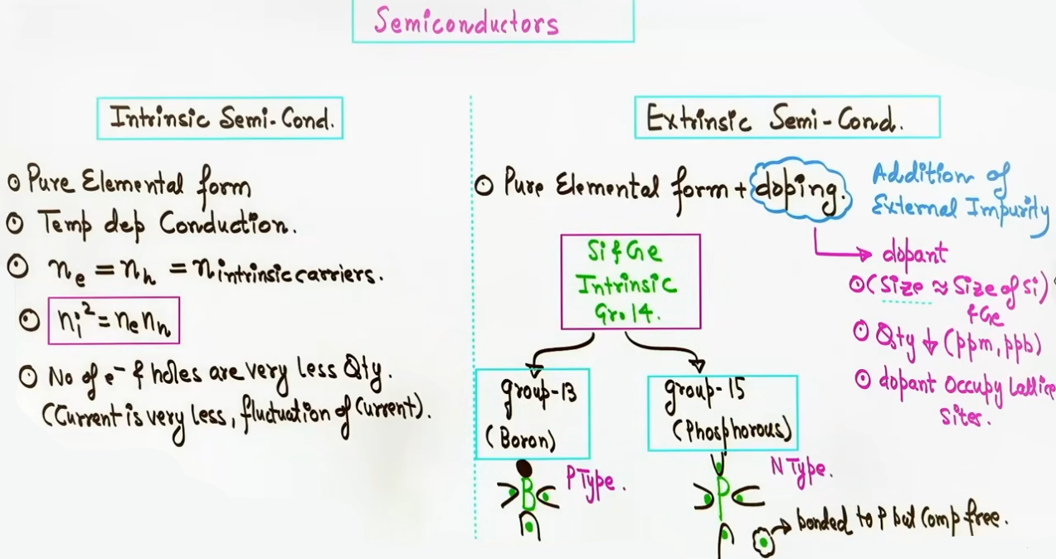
EXTRINSIC SEMICONDUCTORS AND DOPING

Definition: Extrinsic semiconductors are created by deliberately adding controlled amounts of specific impurity atoms (dopants) to pure semiconductors to significantly increase electrical conductivity.
Doping Definition: Doping is the intentional addition of external impurity atoms to an intrinsic semiconductor crystal.
Strict Conditions for Effective Doping:
1. Atomic Size Compatibility: The atomic radius of the dopant must be nearly identical to the host Silicon or Germanium atom so that the host crystal lattice is not distorted or defective.
2. Extremely Low Concentration: The quantity of dopants added must be very small, typically at parts per million (ppm) or parts per billion (ppb) levels (1 impurity atom per 10⁶ to 10⁹ host atoms).
3. Substitutional Occupancy: Dopant atoms must occupy regular lattice sites where host atoms resided, rather than squeezing into interstitial spaces.
- Choice of Dopants: Group 14 elements (Si, Ge) are doped with neighboring Group 13 elements (trivalent) or Group 15 elements (pentavalent) to satisfy size compatibility.

# room temp. m kuch bond tute hote h isliye kuch free electron aur kuch hole pehle se hi hote h.
# nₑ = electron carrier density = no. of electron / Volume
# nₕ = hole carrier density = no. of holes / Volume

P-TYPE EXTRINSIC SEMICONDUCTORS
Formation: Doping pure Silicon or Germanium with Group 13 trivalent elements (such as Boron, Aluminum, Gallium, or Indium).
Bonding Mechanism: A trivalent dopant atom (e.g., Boron) has 3 valence electrons. It forms 3 covalent bonds with 3 adjacent Silicon atoms, leaving 1 vacant bond site (a hole) with the 4th Silicon atom.
Acceptor Atoms: Trivalent dopants are called Acceptor Atoms because they readily accept an electron from a neighboring host covalent bond to complete their octet. Upon accepting an electron, the neutral Boron atom becomes a negatively charged immobile space charge ion (B⁻).
Charge Carriers:
1. Majority Carriers: Holes (nₕ >> nₑ).
2. Minority Carriers: Free Electrons, generated purely by thermal breaking of host bonds.
3. Majority Carrier Density: nₕ ≈ N_A (where N_A is the acceptor dopant concentration).

Acceptor Energy Level (E_A): Positioned slightly above the top of the valence band (E_V). Electrons require very little thermal energy to jump from the valence band into the acceptor level, creating holes in the valence band.
Electrical Neutrality: Bulk P-type semiconductor crystal remains strictly ELECTRICALLY NEUTRAL. The total positive charge (protons in host and dopant nuclei) exactly equals the total negative charge (bound and free electrons).
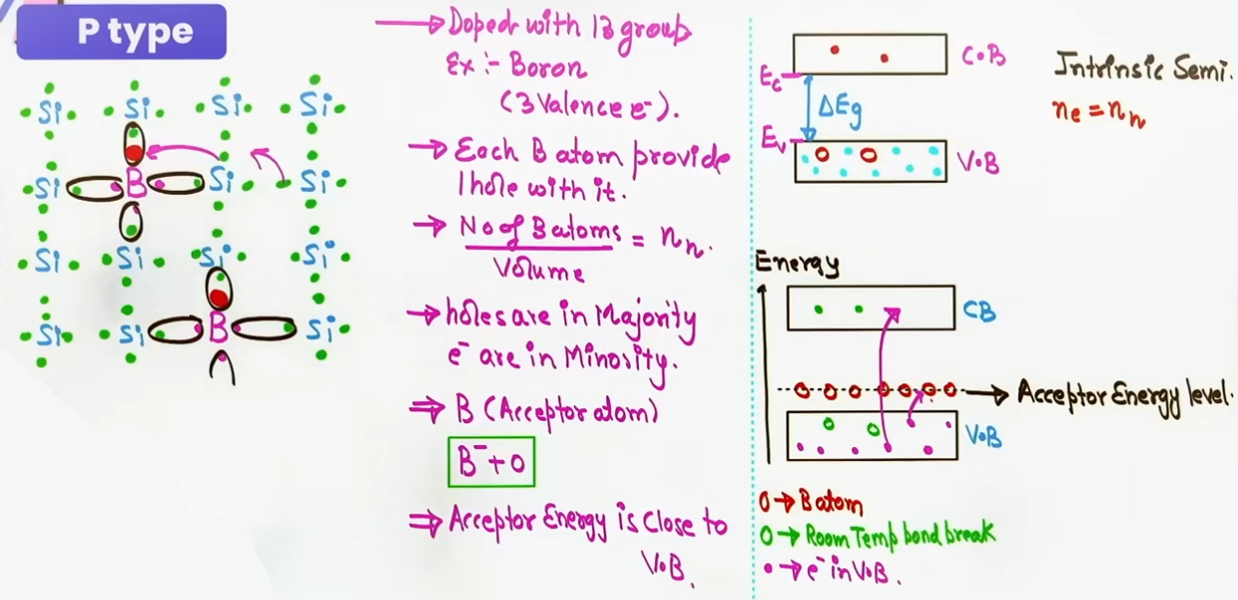
N-TYPE EXTRINSIC SEMICONDUCTORS
Formation: Doping pure Silicon or Germanium with Group 15 pentavalent elements (such as Phosphorus, Arsenic, or Antimony).
Bonding Mechanism: A pentavalent dopant atom (e.g., Phosphorus) has 5 valence electrons. It uses 4 electrons to form covalent bonds with 4 neighboring Silicon atoms. The 5th electron remains weakly attached to the Phosphorus nucleus and is easily liberated into the conduction band at room temperature.
Donor Atoms: Pentavalent dopants are called Donor Atoms because they donate an electron for conduction. Upon donating an electron, the neutral Phosphorus atom becomes a positively charged immobile space charge ion (P⁺).
Charge Carriers:
1. Majority Carriers: Free Electrons (nₑ >> nₕ).
2. Minority Carriers: Holes, generated purely by thermal breaking of host bonds.
3. Majority Carrier Density: nₑ ≈ N_D (where N_D is the donor dopant concentration).
Donor Energy Level (E_D): Positioned slightly below the bottom of the conduction band (E_C). Electrons require very small energy to jump from the donor level into the conduction band.
Electrical Neutrality: Bulk N-type semiconductor crystal is strictly ELECTRICALLY NEUTRAL. Every extra electron provided by a donor atom is balanced by an extra proton in that donor atom's nucleus.
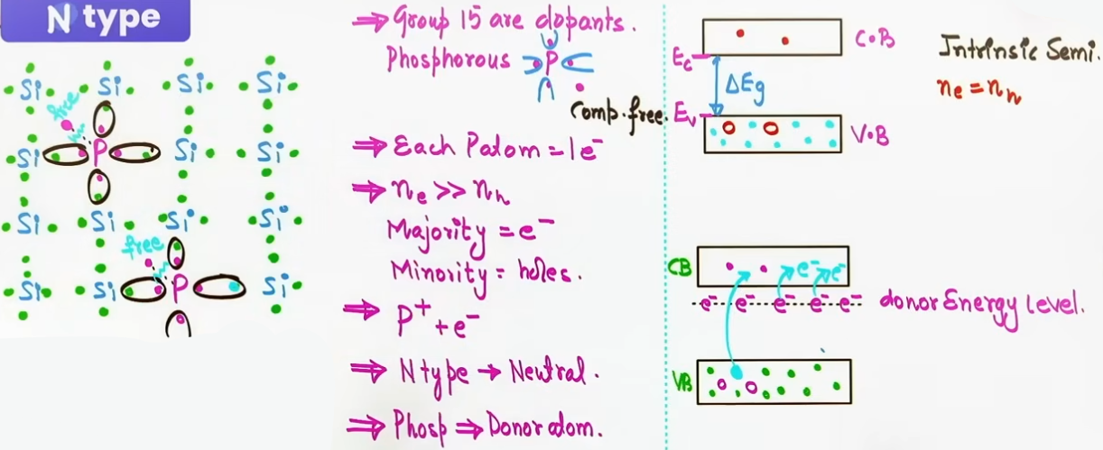
ELECTRICAL CONDUCTIVITY OF SEMICONDUCTORS
Total Current: In semiconductors, total current is the scalar sum of free electron current (Iₑ) in the conduction band and hole current (Iₕ) in the valence band: I = Iₑ + Iₕ.
Microscopic Current Density: J = e·(nₑ·v_de + nₕ·v_dh) = e·E·(nₑ·μₑ + nₕ·μₕ).
Electrical Conductivity Formula: σ = 1/ρ = e·(nₑ·μₑ + nₕ·μₕ).
- Intrinsic Semiconductor: σ = e · nᵢ · (μₑ + μₕ).
- P-Type Semiconductor : σ ≈ e · nₕ · μₕ ≈ e · N_A · μₕ (since nₕ >> nₑ).
- N-Type Semiconductor : σ ≈ e · nₑ · μₑ ≈ e · N_D · μₑ (since nₑ >> nₕ).
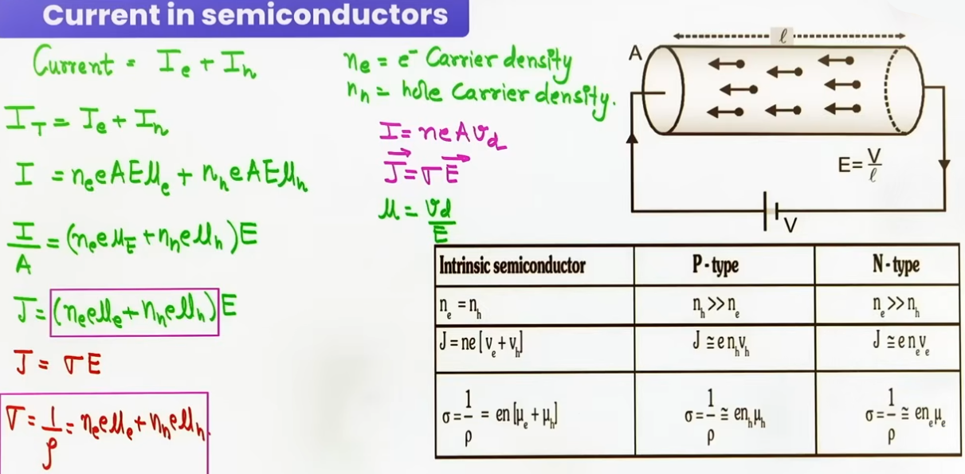
PN JUNCTION FORMATION AND DEPLETION LAYER

Physical Assembly: Joining a P-type semiconductor block with an N-type semiconductor block. In practice, an Aluminum foil interface is placed between them and heated to approximately 500 °C so that a continuous crystal lattice interface is formed.
Step 1: Diffusion Process and Diffusion Current (I_diff)
- Cause: A steep concentration gradient exists across the junction (high hole concentration on P-side, high electron concentration on N-side).
- Action: Holes diffuse from P-side to N-side, and free electrons diffuse from N-side to P-side across the junction interface.
- Direction of Diffusion Current: Directed from P-side to N-side (since electron flow from N to P constitutes current from P to N).
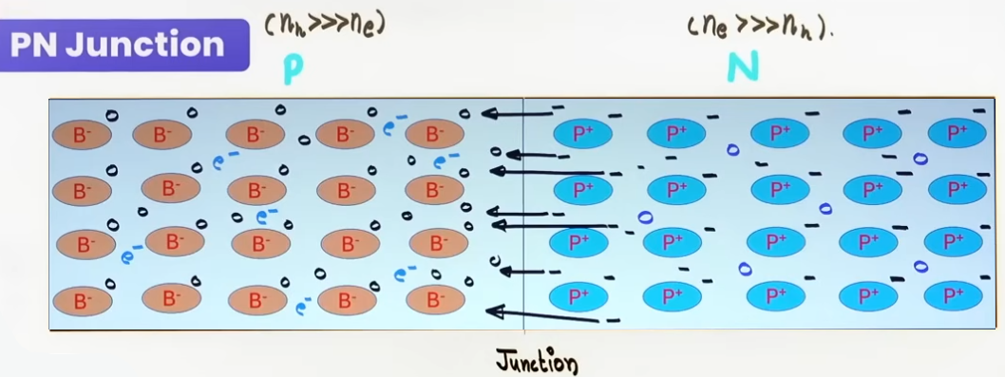
Step 2: Uncovering Immobile Space Charge Ions
- As electrons cross the junction into the P-side, they recombine with holes near the interface and get neutralized.
- This recombination leaves uncompensated immobile space charge ions near the interface: negative acceptor ions (B⁻) on the P-side and positive donor ions (P⁺) on the N-side.
Step 3: Formation of Depletion Layer
- The region surrounding the junction interface becomes depleted of mobile charge carriers (free electrons and holes).
- This central region containing only immobile positive and negative space charge ions is called the Depletion Layer / Depletion Region.
Step 4: Internal Electric Field (E_int) and Barrier Potential (V_B)
- The immobile positive ions on the N-side and negative ions on the P-side set up an internal electric field (E_int) directed from N-side to P-side across the depletion region.
- This electric field creates a potential difference across the depletion width (l) called the Barrier Potential or Potential Barrier (V_B or V₀).
- Mathematical Relation: V_B = E_int · l.
- Standard Barrier Potential Values at Room Temperature: V_B ≈ 0.7 V for Silicon; V_B ≈ 0.3 V for Germanium.
Step 5: Drift Process and Drift Current (I_drift)
- The internal electric field opposes further diffusion of majority carriers across the junction.
- However, the internal field sweeps minority carriers across the junction (minority electrons from P-side to N-side, minority holes from N-side to P-side).
- This minority carrier transport constitutes the Drift Current (I_drift), directed from N-side to P-side.
Step 6: Dynamic Equilibrium
- As diffusion continues, the depletion width increases, strengthening E_int and boosting I_drift.
- Equilibrium is reached when Diffusion Current equals Drift Current in magnitude: |I_diff| = |I_drift|.
- At equilibrium, net current across an unbiased PN junction is zero.
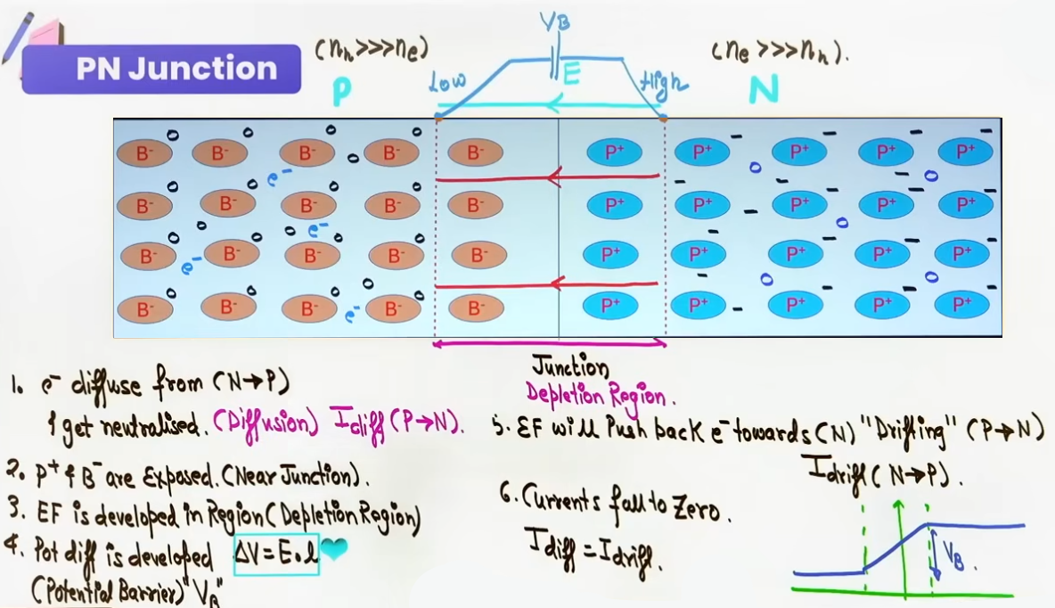
PHYSICAL MECHANISM UNDER BIASING
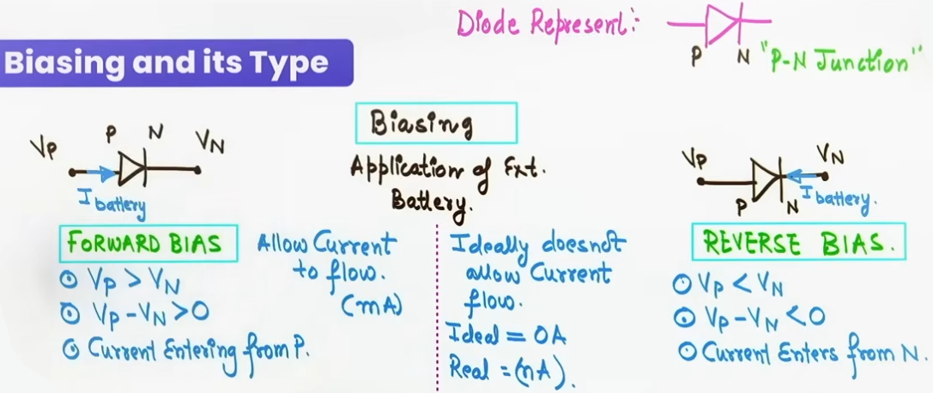
Biasing Definition: Connecting an external DC battery across the terminals of a PN junction diode.
Diode Symbol: Triangle pointing from P to N connected to a vertical bar representing N.

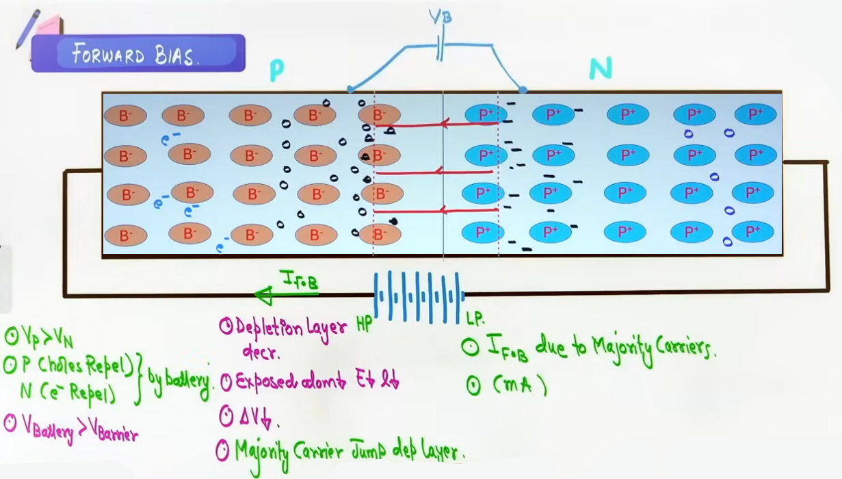
FORWARD BIASING MECHANISM:
- Connection: Positive terminal of battery connected to P-side; negative terminal connected to N-side (V_P > V_N or V_P - V_N > 0).
- Field Alignment: External electric field (E_ext) acts from P to N, directly opposing the internal electric field (E_int).
- Carrier Repulsion: Positive battery terminal repels majority holes in P-side toward the junction; negative terminal repels majority electrons in N-side toward the junction.
- Impact on Depletion Layer:
1. Depletion layer width (l) DECREASES (compresses).
2. Immobile ions are partially neutralized, so Barrier Potential V_B DECREASES (effective barrier = V_B - V_ext).
3. Internal electric field strength DECREASES.
- Conduction Condition: When external applied voltage exceeds the barrier potential (V_ext > V_B), majority carriers gain sufficient energy to jump across the narrowed depletion layer.
- Current Characteristics: Large forward current flows across the junction, primarily carried by majority carriers. Current magnitude is in milliamperes (mA).
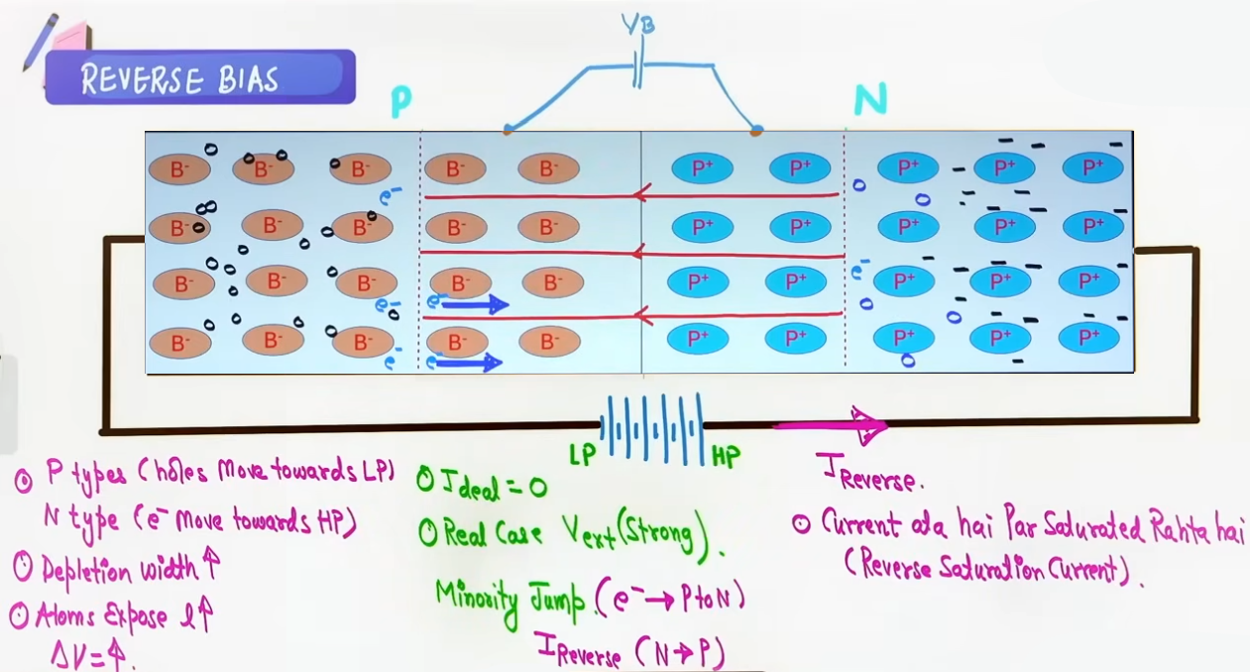
REVERSE BIASING MECHANISM:
- Connection: Positive terminal of battery connected to N-side; negative terminal connected to P-side (V_P < V_N or V_P - V_N < 0).
- Field Alignment: External electric field (E_ext) acts from N to P, in the same direction as the internal electric field (E_int).
- Carrier Attraction: Positive terminal pulls majority electrons in N-side away from junction; negative terminal pulls majority holes in P-side away from junction.
- Impact on Depletion Layer:
1. Depletion layer width (l) INCREASES (expands).
2. More space charge ions are exposed, so Barrier Potential V_B INCREASES (effective barrier = V_B + V_ext).
3. Internal electric field strength INCREASES.
- Conduction Condition: Majority carrier flow is completely blocked by the heightened potential barrier. However, the strong field sweeps thermally generated minority carriers across the junction.
- Current Characteristics: A tiny, nearly constant Reverse Saturation Current flows across the junction, carried exclusively by minority carriers. Current magnitude is in nanoamperes (nA).
- Ideal Diode Assumption: An ideal reverse-biased diode acts as an open circuit with zero current (I = 0) and infinite resistance.
INTUITION AND CONCEPTUAL UNDERSTANDING

- Carrier Generation and Mass Action Intuition:
Think of an intrinsic semiconductor as a quiet room where temperature occasionally creates electron-hole pairs. In an intrinsic material, nₑ = nₕ. When you add pentavalent donor impurities, you flood the room with free electrons. By the Mass Action Law (nᵢ² = nₑ · nₕ), the massive increase in free electrons causes holes to rapidly recombine with electrons, suppressing the hole population far below the intrinsic level.

- Railway Station Stampede Analogy for Biasing:
Teacher's Intuitive Model: Picture a railway platform filled with a panicked crowd (charge carriers) trying to cross train tracks (depletion region) to reach another platform.
- Forward Bias: A security force behind the crowd pushes everyone forcibly toward the tracks. People at the front are forced to jump over the tracks despite the danger, resulting in a massive rush of people crossing (milliamperes of majority current).
- Reverse Bias: The security force pulls the crowd away from the tracks, clearing the platform edge. No majority carrier can jump. The only people crossing are a few stray lost children (minority carriers) being swept across by the track wind (nanoamperes of reverse saturation current).

FORMULA SHEET

- Carrier Density Approximations for Extrinsic Semiconductors:
- For P-Type: nₕ ≈ N_A and nₑ = nᵢ² / N_A (where N_A is Acceptor Concentration),
- For N-Type: nₑ ≈ N_D and nₕ = nᵢ² / N_D (where N_D is Donor Concentration),

- Electrical Conductivity and Resistivity:
σ = 1/ρ = e · (nₑ · μₑ + nₕ · μₕ)
Units: σ in Ω⁻¹·m⁻¹ or S/m; ρ in Ω·m; e = 1.6 × 10⁻¹⁹ C; μ in m²/(V·s).
- Intrinsic: σ = e · nᵢ · (μₑ + μₕ),
- P-Type: σ ≈ e · N_A · μₕ,
- N-Type: σ ≈ e · N_D · μₑ,

- Diode Terminal Biasing Condition Rule:
ΔV_bias = V_P - V_N
- If ΔV_bias > 0 (V_P > V_N): Forward Bias,
- If ΔV_bias < 0 (V_P < V_N): Reverse Bias,
- If ΔV_bias = 0 (V_P = V_N): Unbiased (Zero net current),

Key Formulas:
- Mass Action Law: nᵢ² = nₑ · nₕ
- Conductivity: σ = e · (nₑ · μₑ + nₕ · μₕ)
- Depletion Potential Relation: V_B = E_int · l
- Biasing Check: ΔV_bias = V_P - V_N (ΔV > 0 -> Forward; ΔV < 0 -> Reverse),
- Silicon Barrier V_B = 0.7 V; Germanium Barrier V_B = 0.3 V

Key Principles:
1. Bulk P-type and N-type materials are strictly ELECTRICALLY NEUTRAL.
2. Doping requires atomic size matching, ppm/ppb low concentrations, and substitutional lattice placement.
3. Diffusion current flows from P to N; Drift current flows from N to P.
4. Forward Bias compresses depletion width and lowers barrier height; Reverse Bias expands depletion width and raises barrier height.
5. Forward current is in milliamperes (mA, majority carriers); Reverse saturation current is in nanoamperes (nA, minority carriers).

CONCEPT CONNECTIONS

Property | Intrinsic Semiconductor | P-Type Semiconductor | N-Type Semiconductor
Dopant Added | None (Pure Si/Ge) | Group 13 Trivalent (B, Al, Ga) | Group 15 Pentavalent (P, As, Sb)
Majority Carriers | None (nₑ = nₕ) | Holes (nₕ >> nₑ) | Free Electrons (nₑ>>nₕ)
Minority Carriers | None (nₑ = nₕ) | Free Electrons | Holes
Predominant Ion | None | Immobile Acceptor Ion(B⁻) | Immobile Donor Ion (P⁺)
Energy Level | None (Band Gap ΔE_g) | Acceptor Level E_A near V_V | Donor Level E_D near E_C
Net Charge | Zero (Neutral) | Zero (Neutral) | Zero (Neutral)
Conductivity | Very Low  (e nᵢ (μₑ+μₕ)) | High (≈ e N_A μₕ) | High (≈ e N_D μₑ)

PROBLEM-SOLVING FRAMEWORK

Question Type | Identification Clues | Approach / Strategy | Common Mistakes | Fast Methods / Shortcuts
Ideal Diode Circuit Analysis | Resistor network containing ideal diodes | 1. Identify bias state of each diode using V_P - V_N. 2. Replace Forward Ideal Diodes with short circuit wires. 3. Replace Reverse Ideal Diodes with open circuit breaks. 4. Solve resulting circuit using Ohm's Law/KVL. | Leaving reverse-biased diode branches in the circuit calculation. | Erase reverse-biased diode branches completely from schematic.
Real Diode Circuit Analysis | Diode with given knee voltage V_k (0.7V for Si) and forward resistance R_f | 1. Verify Forward Bias. 2. Replace diode with an opposing battery of EMF = V_k and series resistor R_f. 3. Net EMF = V_supply - V_k. 4. Current I = (V_supply - V_k) / (R_total + R_f). | Adding knee voltage to supply voltage instead of subtracting it. | Net V = V_supply - V_k.

JEE ADVANCED INSIGHTS

1. Asymmetric Doping and Depletion Layer Penetration:
The depletion layer does not extend equally into P and N sides if doping levels differ. By charge conservation, total negative space charge on P-side must equal total positive space charge on N-side: q · N_A · x_P = q · N_D · x_N.
Therefore, x_P / x_N = N_D / N_A.
The depletion layer penetrates deeper into the lighter-doped side! If N_A >> N_D (P⁺N junction), the depletion region lies almost entirely inside the N-side.

2. Origin of Minority Carrier Reverse Saturation Current:
Reverse saturation current I_S is independent of applied reverse voltage V_ext because it is strictly limited by the rate of thermal electron-hole pair generation in the depletion layer and within a diffusion length of the junction. I_S doubles approximately for every 10 °C rise in temperature.

COMMON MISTAKES AND TRAPS
Mistake | Why Students Make It | Correct Approach / Thinking
Believing P-type is positively charged and N-type is negatively charged | Confusing majority charge carrier sign with net crystal charge | Bulk P-type and N-type semiconductors are strictly ELECTRICALLY NEUTRAL. Doping adds neutral atoms.
Assuming negative terminal voltage always implies Reverse Bias | Checking individual terminal voltage signs instead of potential difference V_P - V_N | Always calculate ΔV = V_P - V_N. Example: V_P = -2V, V_N = -7V -> ΔV = +5V > 0 (FORWARD BIAS!).
Believing Reverse Saturation Current increases with reverse voltage | Expecting Ohm's Law behavior in reverse bias | Reverse saturation current I_S is constant (saturated) because it is limited by thermal minority carrier generation rate.
Thinking depletion layer contains mobile charge carriers | Confusing depletion layer with conduction zone | Depletion layer is DEPLETED of mobile carriers; it contains ONLY immobile fixed space charge ions.
Assuming Drift Current flows from P to N | Confusing Diffusion Current direction with Drift Current direction | Diffusion Current flows from P to N. Drift Current flows from N to P.

LAST-MINUTE REVISION TABLE:
Concept / Parameter | Intrinsic / Unbiased State | Forward Bias State | Reverse Bias State
Majority Carrier Flow | Balanced by drift at equilibrium | Massive injection across junction | Completely blocked by barrier
Minority Carrier Flow | Balanced by diffusion at equilibrium | Negligible relative contribution | Dominates reverse current (nA)
Depletion Layer Width (l) | Equilibrium width l₀ | Decreases (l < l₀) | Increases (l > l₀)
Effective Barrier Height | V_B(0.7V Si, 0.3V Ge) | Decreases (V_B - V_ext) | Increases (V_B + V_ext)
Internal Electric Field | E_int = V_B / l | Opposed and weakened | Aided and strengthened
Diode Circuit Equivalent | Net zero current (I=0) | Closed switch / Short wire | Open switch / Break (I ≈ 0)
Typical Current Magnitude | Zero net current | Milliamperes (mA) | Nanoamperes (nA)
Diode Dynamic Resistance | Variable | Low (~ 10 to 100 Ω) | Extremely high (~ 10⁶ Ω / ∞)
Carrier Transport Process | Diffusion = Drift | Diffusion dominates | Drift dominates
Bulk Neutrality Status | Neutral | Neutral | Neutral

LAST-MINUTE CHECKLIST:
- Did you calculate V_P - V_N to check biasing?,
- Did you convert micrometers/nanometers to meters in V_B = E · l?,
- Is the diode ideal or real (does it have a 0.7 V knee voltage)?
- Remember: P-type has excess holes, N-type has excess electrons, but BOTH ARE ELECTRICALLY NEUTRAL!,
- Remember: Diffusion goes P to N; Drift goes N to P!
- Remember: Reverse saturation current is independent of applied voltage!
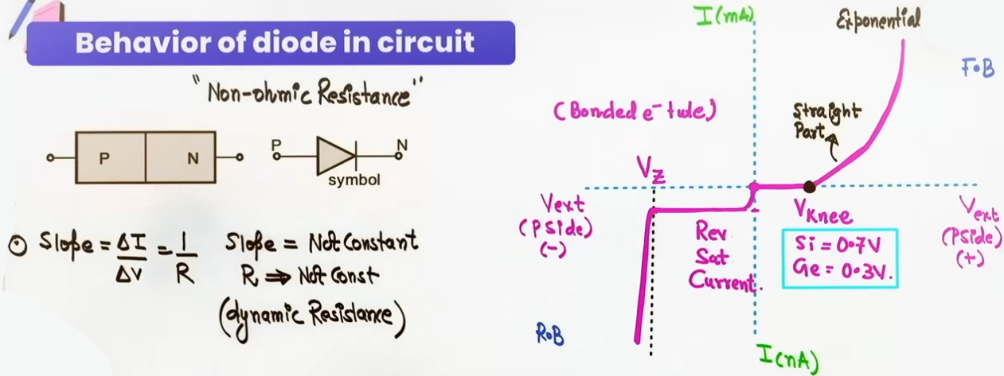
V-I CHARACTERISTIC CURVES AND DYNAMIC RESISTANCE
V-I Characteristic Setup:
- A graph plotted between external voltage (V_ext) applied across a PN junction diode on the X-axis and resulting current (I) through the diode on the Y-axis.
- The graph is divided into two operational quadrants: First Quadrant for Forward Bias and Third Quadrant for Reverse Bias.

Forward V-I Characteristic:
1. Knee Voltage / Cut-in Voltage (V_k): Current remains nearly zero until external forward voltage overcomes the internal barrier potential (V_B). The threshold voltage where current starts increasing noticeably is called the Knee Voltage (V_k).
2. Values: V_k ≈ 0.7 V for Silicon; V_k ≈ 0.3 V for Germanium.
3. Exponential Rise: For V > V_k, forward current increases exponentially with applied voltage.

Reverse V-I Characteristic:
1. Reverse Saturation Current (I_S): A tiny, nearly constant reverse current flows due to thermally generated minority carriers crossing the junction.
2. Saturation Reason: Limited by the fixed rate of thermal minority carrier generation, making the current independent of applied reverse voltage.
3. Current Magnitude: Measured in nanoamperes (nA).
4. Reverse Breakdown Voltage / Zener Voltage (V_Z): When reverse voltage reaches a critical high value (V_Z), the strong electric field ruptures covalent bonds, generating massive charge carriers and causing reverse current to spike sharply.

Non-Ohmic Behavior and Dynamic Resistance (R_dynamic):
- Because the V-I characteristic curve is non-linear, a diode does not obey Ohm's Law overall (non-ohmic element).
- Resistance changes at every operating point on the curve.
- Dynamic Resistance Formula:
R_dynamic = ΔV / ΔI = 1 / (slope of V-I curve)
- In forward bias above knee voltage, dynamic resistance is very low.
- In reverse bias below breakdown, dynamic resistance is extremely high.
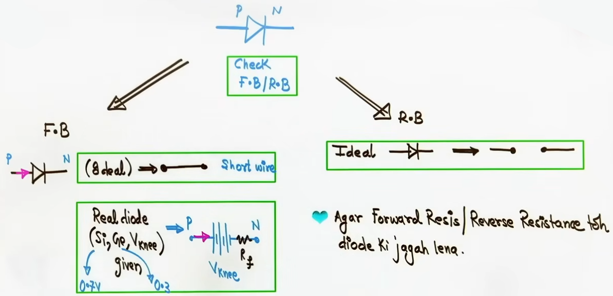
DIODE CIRCUIT ANALYSIS AND PROBLEM-SOLVING STRATEGIES

- Step 1: Check Diode Biasing State
Calculate potential difference across diode terminals: ΔV_bias = V_P - V_N.
If ΔV_bias > 0 (V_P > V_N): Diode is FORWARD BIASED.
If ΔV_bias < 0 (V_P < V_N): Diode is REVERSE BIASED.

- Step 2: Ideal Diode Equivalent Circuit Replacement
Forward Biased Ideal Diode: Replace diode with a short-circuit wire.
Reverse Biased Ideal Diode: Replace diode with an open-circuit break.

- Step 3: Real Diode Equivalent Circuit Replacement
Forward Biased Real Diode:
1. If Knee Voltage V_k is given (e.g., 0.7 V for Si or 0.3 V for Ge): Replace diode with an opposing battery of EMF = V_k (positive terminal facing P-side, negative terminal facing N-side).
2. If Forward Resistance R_f is also given: Add resistor R_f in series with opposing battery V_k.
3. Net Circuit Voltage: V_net = V_supply – V_k.

Reverse Biased Real Diode: Replace diode with an open-circuit break, unless a reverse resistance R_r (e.g., 1000 Ω) is explicitly specified, in which case replace diode with resistor R_r.

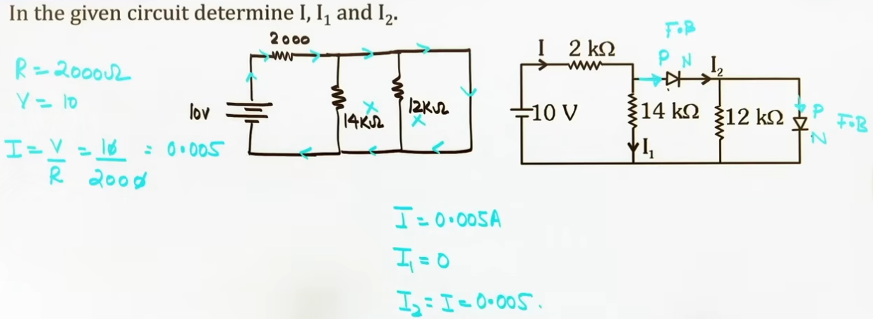

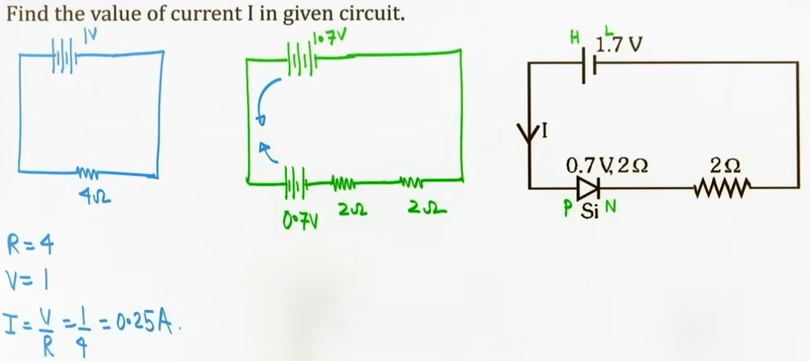
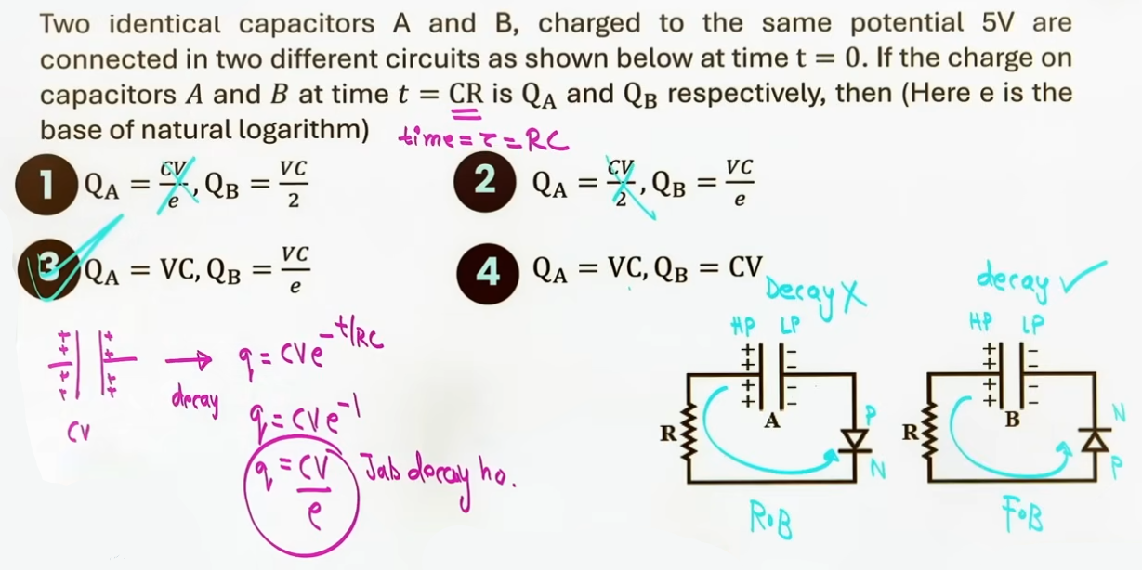
APPLICATIONS OF PN JUNCTION (#5 points h)

1. RECTIFIERS
Definition and Purpose:
- Rectification is the process of converting alternating current (AC) into unidirectional pulsating direct current (DC) using the one-way conduction property of a PN junction diode.
- Difference from Transformer: A transformer modifies AC voltage levels (step-up or step-down) but retains AC; a rectifier converts AC into DC.

Half-Wave Rectifier:
1. Circuit Configuration: Consists of a single diode connected in series with the secondary winding of a transformer and a load resistor (R_L).
2. Operation: Conducts only during positive half-cycles of input AC (diode forward biased). During negative half-cycles, diode is reverse biased and acts as an open circuit (zero current).
3. Efficiency: η ≈ 40.6%.
4. Output Ripple Frequency: Equal to input AC frequency (f_out = f_in).
5. Output Time Period: T_out = T_in.
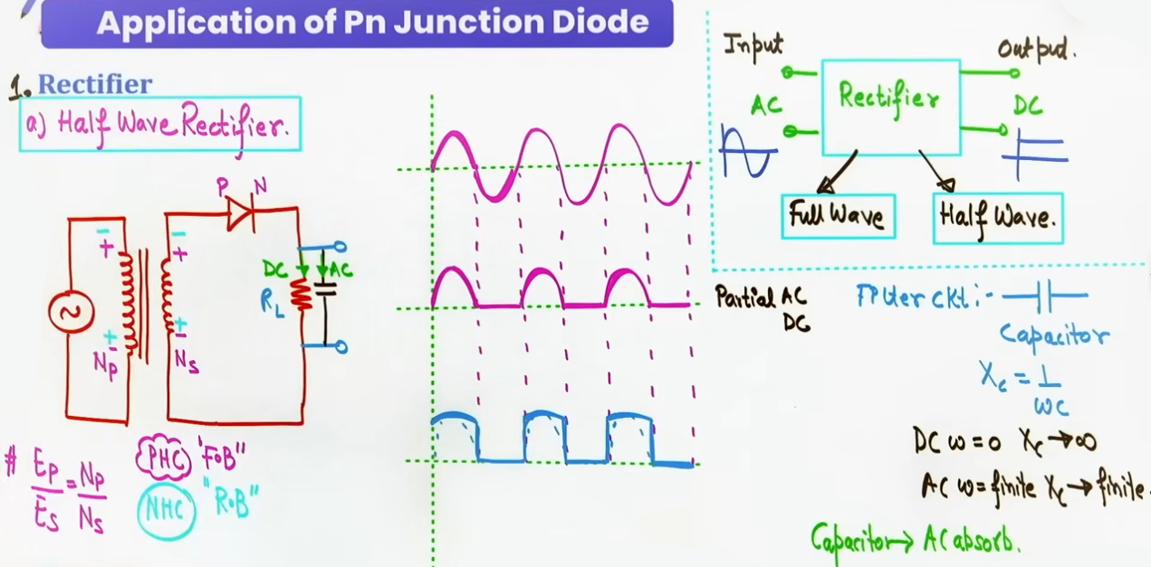

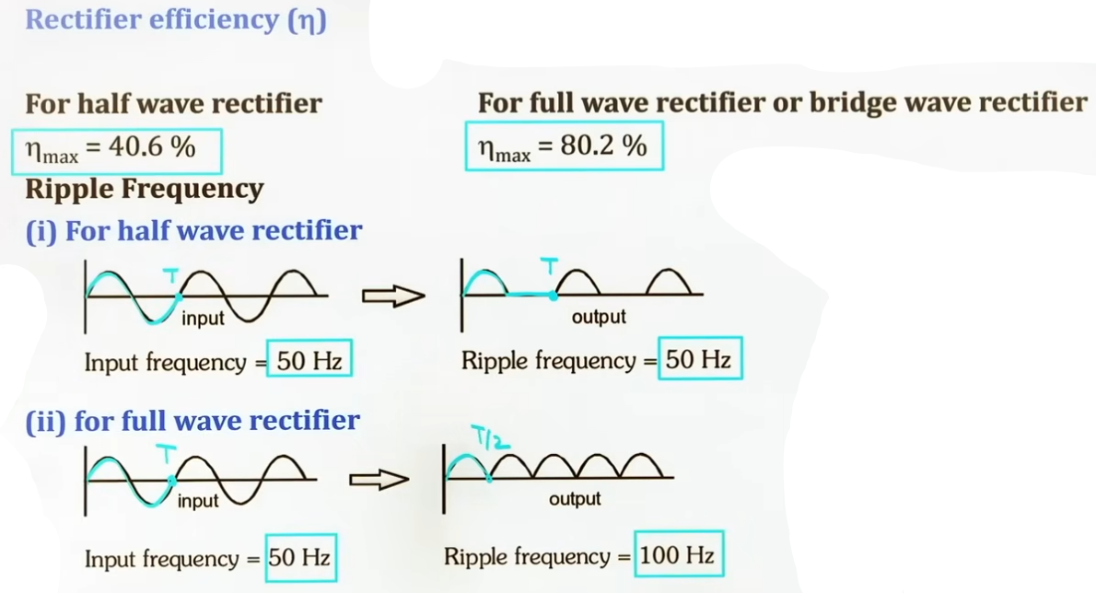
Full-Wave Center-Tapped Rectifier:
1. Circuit Configuration: Consists of two diodes (D₁ and D₂) connected across a center-tapped secondary transformer winding and a common load resistor R_L.
2. Operation: Center-tap divides secondary voltage into two equal halves. During positive half-cycle, D₁ is forward biased and conducts while D₂ is reverse biased. During negative half-cycle, D₂ is forward biased and conducts while D₁ is reverse biased. Current flows through R_L in the same direction during both half-cycles.
3. Efficiency: η ≈ 81.2%.
4. Output Ripple Frequency: Double the input AC frequency (f_out = 2 * f_in).
5. Output Time Period: T_out = T_in / 2.

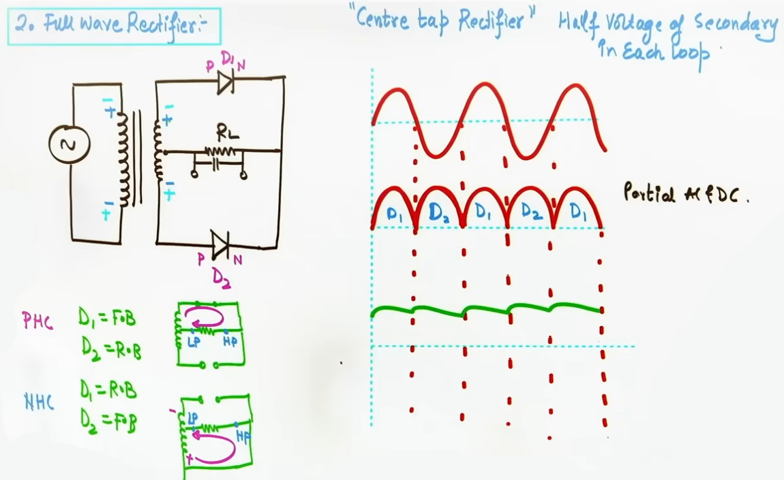
Filter Circuits (Capacitor Filter):
1. Purpose: Smooths pulsating DC output from rectifiers into steady DC.
2. Construction: A capacitor (C) connected in parallel with load resistor R_L.
3. Operating Mechanism: Capacitive reactance is X_C = 1 / (2πfC).
For DC component (f = 0): X_C = ∞. Capacitor blocks DC completely, forcing all DC current through load R_L.
For AC ripple component (f > 0): X_C is small. Capacitor bypasses AC ripples to ground and charges up during voltage peaks, discharging through R_L during troughs to maintain a steady output voltage.
"OPTOELECTRONIC DIODES"

2. Photo Diode:
1. Biasing Mode: Operated strictly in “REVERSE BIAS”.
2. Primary Function: Detects optical signals and measures light intensity.
3. Working Mechanism: When incident light photons with energy E = h·ν ≥ ΔE_g strike the depletion region, covalent bonds break, generating electron-hole pairs.
4. Current Enhancement: Internal electric field sweeps generated electrons to N-side and holes to P-side before recombination. This increases reverse current significantly above dark current (current in darkness).
5. Sensitivity Factor: Reverse bias is chosen because the relative fractional change in minority current (ΔI / I_reverse) due to light is massive and easily detectable compared to majority current in forward bias.
6. Proportionality: Photo-current is directly proportional to incident light intensity.

3. Light Emitting Diode (LED):
1. Biasing Mode: Operated strictly in “FORWARD BIAS”.
2. Primary Function: Converts electrical energy into light emission.
3. Working Mechanism: Forward bias injects majority carriers across the junction. In the depletion layer, free electrons recombine with holes (radiative recombination).
4. Energy Release: Recombination drops electrons into lower bound energy states, releasing energy as photons.
5. Wavelength Condition: For visible light emission, the semiconductor band gap must satisfy 1.8 eV ≤ ΔE_g ≤ 3.1 eV, corresponding to visible wavelengths between 4000 Å and 8000 Å (e.g., Gallium Arsenide Phosphide).

4. Solar Cell:
1. Biasing Mode: Operated “WITHOUT EXTERNAL BIAS” (Unbiased, V_ext = 0).
2. Primary Function: Converts solar radiant energy directly into electrical power.
3. Working Mechanism: Designed with an extremely thin top P-layer so sunlight reaches the depletion region.
4. Photovoltage Generation: Solar photons (h·ν ≥ ΔE_g) generate electron-hole pairs in the depletion layer. The built-in internal electric field separates them, pulling electrons to the N-side and pushing holes to the P-side. This accumulation creates an open-circuit photovoltage (V_oc) across the terminals.

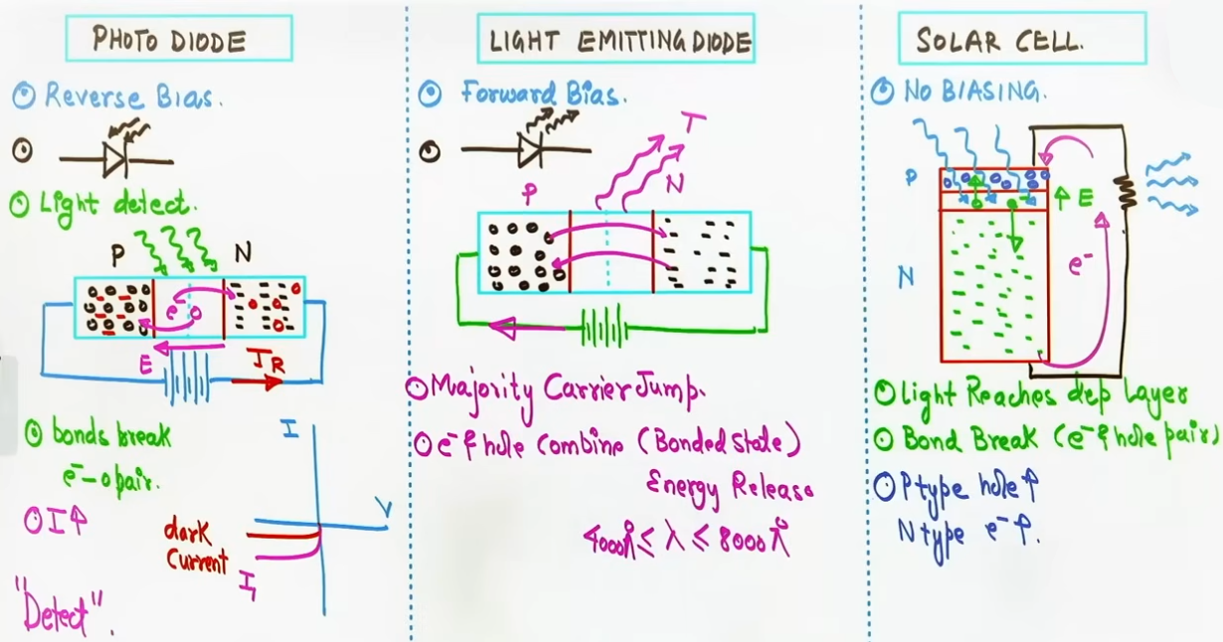
5. ZENER DIODE AND VOLTAGE REGULATOR
Definition and Characteristics:
- A Zener Diode is a heavily doped PN junction diode with an extremely thin depletion layer (~ 10⁻⁶ m) and high internal electric field (~ 10⁶ V/m).
- Symbol: Standard diode symbol with a Z-shaped bar on the N-side.
- Operational Versatility: Behaves like a normal diode in forward bias, acts as an open circuit in low reverse bias, and operates safely in reverse breakdown without destruction.
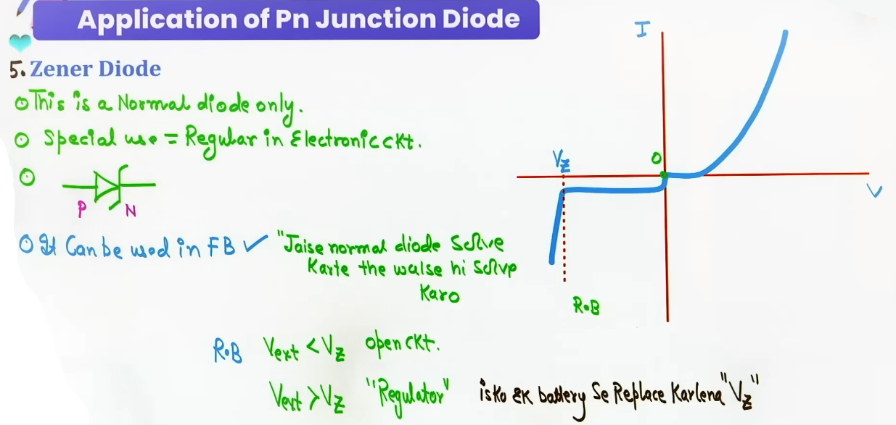
Zener Diode as a Voltage Regulator:
1. Circuit Setup: Connected in REVERSE BIAS in parallel with load resistor R_L across an unregulated DC voltage supply (V_in) with a series resistor R_s.
2. Regulation Condition: Input voltage must exceed Zener breakdown voltage (V_in > V_Z).
3. Regulation Mechanism: In reverse breakdown, large fluctuations in total input current cause large variations in Zener current (I_Z), while voltage across the Zener remains fixed at V_Z. Consequently, load voltage V_L remains perfectly regulated at V_Z.
4. Circuit Equations:
Voltage across load: V_L = V_Z
Current through load: I_L = V_L / R_L = V_Z / R_L
Total input current: I_total = (V_in - V_Z) / R_s
Current through Zener: I_Z = I_total - I_L
Power dissipated in Zener: P_Z = V_Z · I_Z
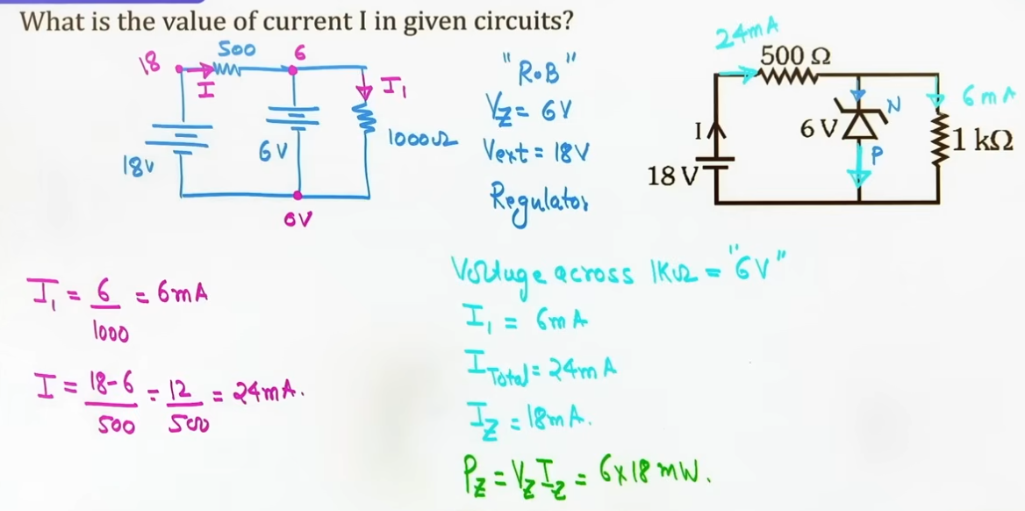
# diode ko hatayenge toh ulti battery lagayenge
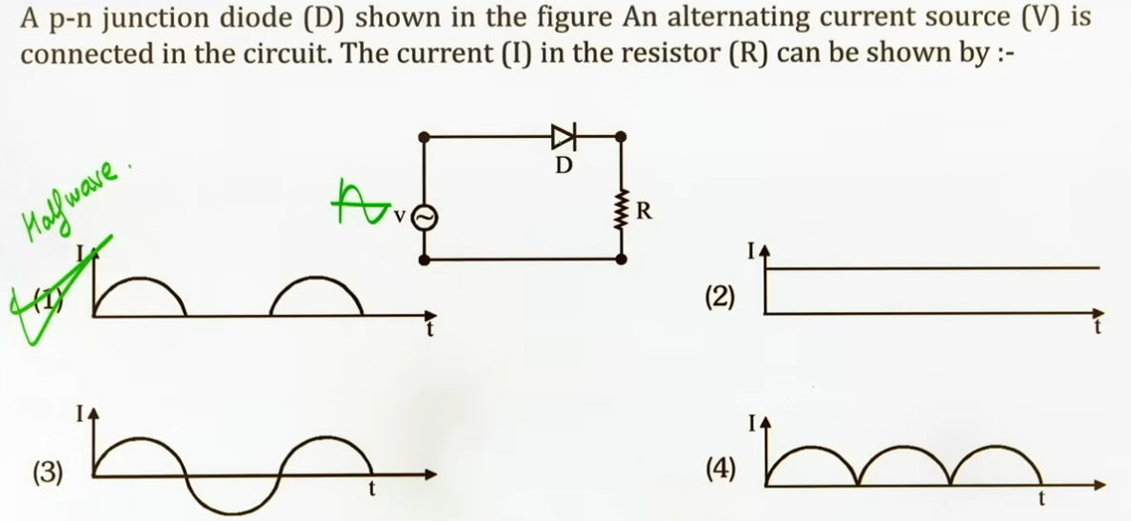
INTUITION AND CONCEPTUAL UNDERSTANDING

- Dynamic Resistance Visualization:
Think of a diode as an unyielding heavy spring door. Below knee voltage (0.7 V for Si), the door does not budge (infinite resistance). Once pushed beyond 0.7 V, the door swings wide open, offering minimal resistance to electron flow (low dynamic resistance).

- Rectifier and Filter Analogy:
A rectifier diode acts like a one-way mechanical check valve that allows water to flow in spurts along one direction only. Connecting a filter capacitor across the load is like attaching a water reservoir tank: during high-pressure spurts, the tank fills up; during low-pressure gaps, the tank discharges water to maintain a steady flow.

- Zener Voltage Regulator Overflow Analogy:
Imagine a water tank equipped with a side overflow weir set at height V_Z. Any incoming water head (V_in) above V_Z spills over the weir (dumped through Zener current I_Z and absorbed by series resistor R_s), keeping the water level supplied to the house (load R_L) fixed precisely at V_Z.

FORMULA SHEET
- Diode Terminal Biasing Check:
ΔV_bias = V_P - V_N
Forward Bias if ΔV_bias > 0
Reverse Bias if ΔV_bias < 0

- Filter Capacitor Reactance:
X_C = 1 / (2πfC)
For DC (f = 0): X_C = ∞ (blocks DC)

- Optoelectronic Wavelength-Energy Relation:
E = h·ν = (h·c) / λ ≥ ΔE_g
λ_max = 1240 / ΔE_g(in eV) nm

Key Formulas:
- Dynamic Resistance: R_dyn = ΔV / ΔI = 1 / (slope of V-I curve)
- Knee Voltages: Silicon V_k = 0.7 V; Germanium V_k = 0.3 V
- Half-Wave Rectifier: Efficiency η = 40.6%, f_ripple = f_in
- Full-Wave Rectifier: Efficiency η = 81.2%, f_ripple = 2 · f_in
- Zener Regulator: V_L = V_Z, I_total = (V_in - V_Z) / R_s, I_Z = I_total - I_L, P_Z = V_Z · I_Z
- Photo Diode Threshold Wavelength: λ_max = 1240 / ΔE_g(in eV) nm
Key Principles:
1. Photo Diode operates in REVERSE BIAS; LED operates in FORWARD BIAS; Solar Cell operates UNBIASED.
2. Zener Diode regulates voltage in REVERSE BREAKDOWN by maintaining V_L = V_Z.
3. Forward bias compresses depletion layer and lowers barrier potential; Reverse bias expands depletion layer and raises barrier potential.

CONCEPT CONNECTIONS

- Connection to Current Electricity & Circuit Laws:
Diode circuit analysis applies Nodal Analysis, Kirchhoff's Voltage Law (KVL), and Microscopic Ohm's Law (J = σE). Real diodes act as non-ideal voltage sources combined with internal resistance.

- Connection to Optics and Quantum Physics:
Optoelectronic devices connect semiconductor band gap transitions to photon energy relations (E = h·c / λ = 1240 / λ(nm) eV).

Comparison Table: Optoelectronic Diodes
+-------------+--------------+------------------+------------------------------+
| Device | Biasing Mode | Primary Function | Key Operating Mechanism |
+-------------+--------------+------------------+------------------------------+
| Photo Diode | Reverse Bias | Light detection | Light breaks bonds -> |
| | | | generates e⁻-h⁺ pairs -> |
| | | | increases reverse current |
+-------------+--------------+------------------+------------------------------+
| LED | Forward Bias | Light emission | Inject majority carriers -> |
| | | | radiative recombination -> |
| | | | emits photons |
+-------------+--------------+------------------+------------------------------+
| Solar Cell | Unbiased | Power generation |Photons generate e⁻-h⁺ pairs->|
| | | |separated by built-in field ->|
| | | | photovoltage V_oc |
+-------------+--------------+------------------+------------------------------+

JEE ADVANCED INSIGHTS

1. Why Photo Diodes are Operated in Reverse Bias:
In forward bias, majority carrier current is large (mA). A small change in carrier concentration due to incident light produces an imperceptible fractional change in total current: ΔI / I_forward ≈ 0.
In reverse bias, current is tiny (nA). Photon-generated electron-hole pairs produce a massive fractional change in reverse current: ΔI / I_reverse >> 0, making signal detection vastly more sensitive.

2. Operating Versatility of Zener Diode:
A Zener diode can operate in three distinct circuit modes:
- Forward Bias: Acts like a normal forward-biased diode (knee voltage 0.7 V).
- Reverse Bias (V_ext < V_Z): Acts like an open circuit with negligible leakage current.
- Reverse Breakdown (V_ext ≥ V_Z): Operates as a constant Voltage Regulator maintaining V_L = V_Z.

3. Capacitor Filter DC Blocking Mechanism:
Because capacitive reactance X_C = 1 / (2πfC) approaches infinity for DC (f = 0), a filter capacitor connected in parallel with load R_L acts as an open circuit to DC, forcing all DC current to flow into load R_L while bypassing AC ripples to ground.

--------------------------------------------------------------------------------
LOGIC GATES

DIGITAL CONCEPTS AND SIGNAL LEVELS

Definition of Logic Gates:
- Logic gates are digital electronic circuits built using components like resistors, diodes, capacitors, inductors, op-amps, and transistors. They process one or more binary input signals according to specific logical rules to deliver a single output signal.
Digital Logic Signal Representation:
- Digital circuits operate on binary states:
Low Voltage Level (0 V) represents Logic 0.
High Voltage Level (+5 V) represents Logic 1.
Bits and Bytes:
- A single binary digit (0 or 1) is called a bit. A structured sequence or combination of bits forms a byte.
Input Combinations Rule:
- For a logic gate with n binary inputs, the total number of possible input combinations is 2ⁿ.
For 2 inputs (n = 2): 2² = 4 possible combinations (00, 01, 10, 11).
For 3 inputs (n = 3): 2³ = 8 possible combinations (000, 001, 010, 011, 100, 101, 110, 111).

BASIC LOGIC GATES

1. OR Gate:
Boolean Expression: Y = A + B (where "+" represents the logical OR operation, not arithmetic addition).
Operating Rule: Output Y = 1 if ANY input is 1. Output Y = 0 only when ALL inputs are 0.
Truth Table:
Input A | Input B | Output Y
0 | 0 | 0
0 | 1 | 1
1 | 0 | 1
1 | 1 | 1

2. AND Gate:
Boolean Expression: Y = A · B (where "·" represents the logical AND operation, not arithmetic multiplication).
Operating Rule: Output Y = 1 ONLY when ALL inputs are 1. Output Y = 0 if ANY input is 0.
Truth Table:
Input A | Input B | Output Y
0 | 0 | 0
0 | 1 | 0
1 | 0 | 0
1 | 1 | 1

3. NOT Gate (Inverter / Reversible Gate):
Boolean Expression: Y = A_bar (or Y = A').
Operating Rule: Possesses a single input. Output Y is the exact inverse or complement of the input.
Truth Table:
Input A | Output Y
0 | 1
1 | 0

UNIVERSAL LOGIC GATES
Definition of Universal Gates:
- NAND and NOR gates are classified as Universal Logic Gates because any basic logic operation (OR, AND, NOT) or complex digital system can be fully constructed using exclusively NAND or exclusively NOR gates.

1. NAND Gate:
Physical Mechanism: Formed by placing a NOT gate (inverter) at the output of an AND gate.
Boolean Expression: Y = (A · B)_bar.
Operating Rule: Inverts the output of an AND gate. Output Y = 0 ONLY when ALL inputs are 1; otherwise, Y = 1.
Truth Table:
Input A | Input B | Output Y
0 | 0 | 1
0 | 1 | 1
1 | 0 | 1
1 | 1 | 0

2. NOR Gate:
Physical Mechanism: Formed by placing a NOT gate (inverter) at the output of an OR gate.
Boolean Expression: Y = (A + B)_bar.
Operating Rule: Inverts the output of an OR gate. Output Y = 1 ONLY when ALL inputs are 0; otherwise, Y = 0.
Truth Table:
Input A | Input B | Output Y
0 | 0 | 1
0 | 1 | 0
1 | 0 | 0
1 | 1 | 0

BOOLEAN ALGEBRA RULES AND DE MORGAN'S LAWS
- Additive Identities (OR Operations):
A + 0 = A
A + 1 = 1 (since any input of 1 forces an OR output to 1)
A + A = A (NOT 2A!)
- Multiplicative Identities (AND Operations):
A · 0 = 0
A · 1 = A
A · A = A (NOT A²!)
- Complement and Double Negation Rules:
A + A_bar = 1
A · A_bar = 0
A_bar_bar = A (double complement returns original state)
- De Morgan's Theorems ("Break the line, change the sign"):
First Theorem: The complement of an OR sum equals the AND product of individual complements.
Formula: (A + B)_bar = A_bar · B_bar
Second Theorem: The complement of an AND product equals the OR sum of individual complements.
Formula: (A · B)_bar = A_bar + B_bar

SPECIAL LOGIC GATES
1. EX-OR (XOR) Gate (Exclusive OR):
Boolean Expression: Y = A_bar · B + A · B_bar = A ⊕ B.
Operating Rule: Output Y = 1 when inputs are DIFFERENT (exclusively one input is 1); Y = 0 when inputs are IDENTICAL.
Truth Table:
Input A | Input B | Output Y
0 | 0 | 0
0 | 1 | 1
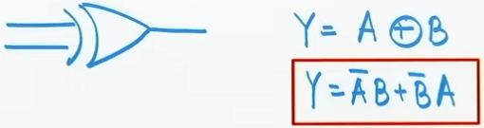
1 | 0 | 1
1 | 1 | 0

2. EX-NOR (XNOR) Gate (Exclusive NOR):
Boolean Expression: Y = A · B + A_bar · B_bar = A ⊙ B.
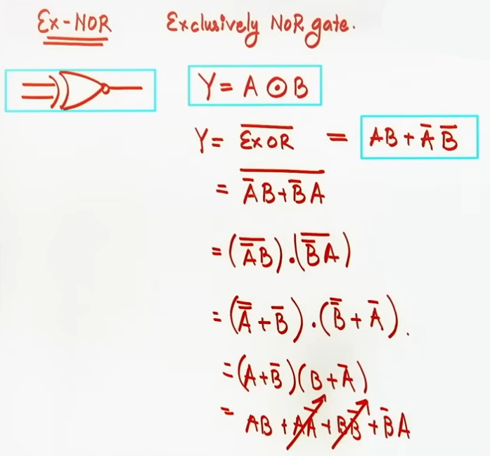
Operating Rule: Inversion of XOR gate. Output Y = 1 when inputs are IDENTICAL; Y = 0 when inputs are DIFFERENT.
Truth Table:
Input A | Input B | Output Y
0 | 0 | 1
0 | 1 | 0
1 | 0 | 0
1 | 1 | 1

COMBINATION CIRCUIT ANALYSIS & TIMING DIAGRAMS
- Node-by-Node Expression Derivation:
To analyze combination logic circuits, write down the output Boolean expression at the exit of each intermediate gate from left to right. Apply De Morgan's laws and Boolean identities to simplify the final output expression.
- Single-Input Conversion of Universal Gates into NOT Gates:
Tying both input terminals of a NAND or NOR gate together converts it into a NOT gate (Inverter):
For NAND: A · A = A ⇒ (A · A)_bar = A_bar.
For NOR: A + A = A ⇒ (A + A)_bar = A_bar.
- Timing Diagram / Waveform Analysis:
Input waveforms display digital voltage levels over time intervals. Divide the timeline into discrete intervals wherever any input changes state (0 V or +5 V). Evaluate the output state interval-by-interval to sketch or identify the output waveform.
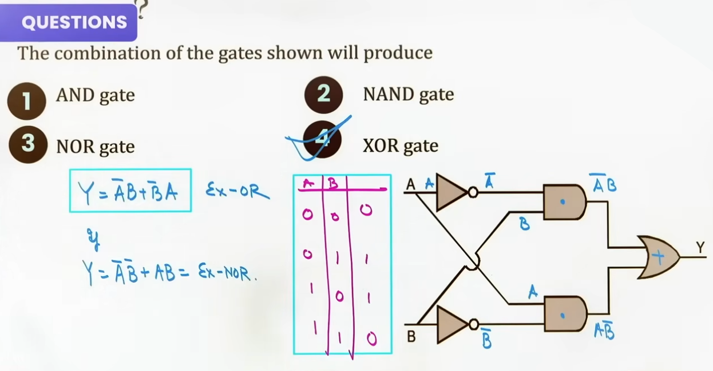
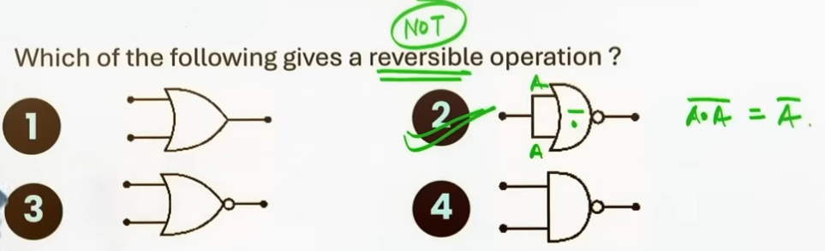
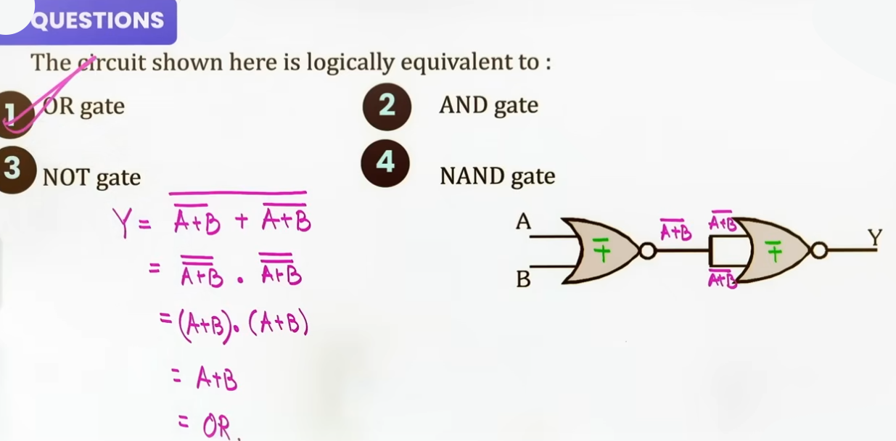
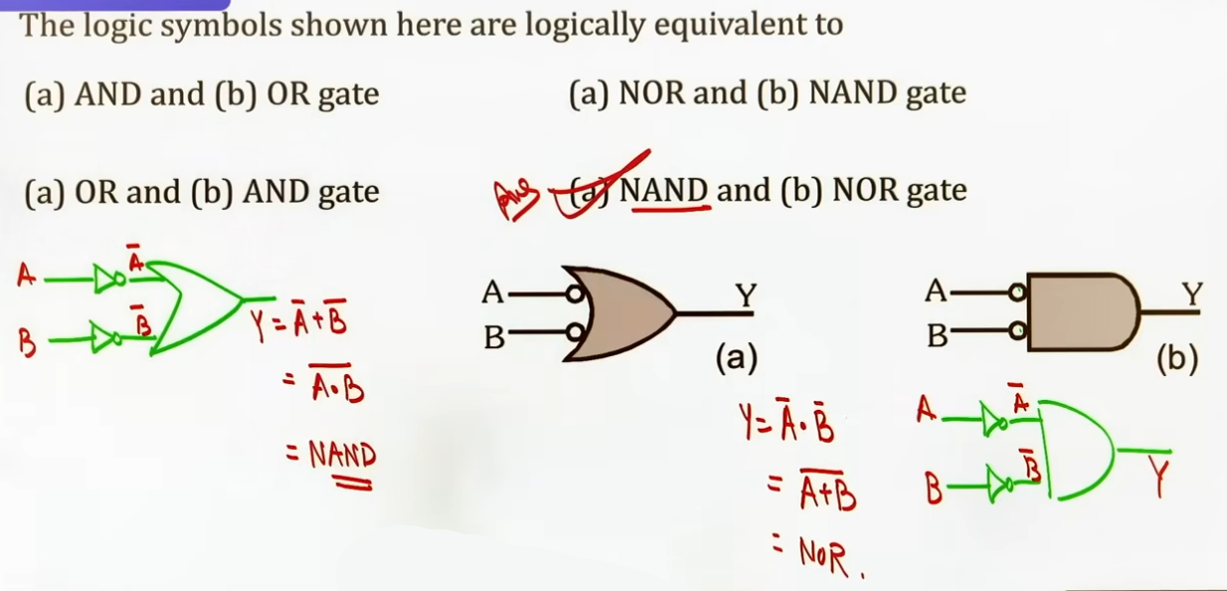
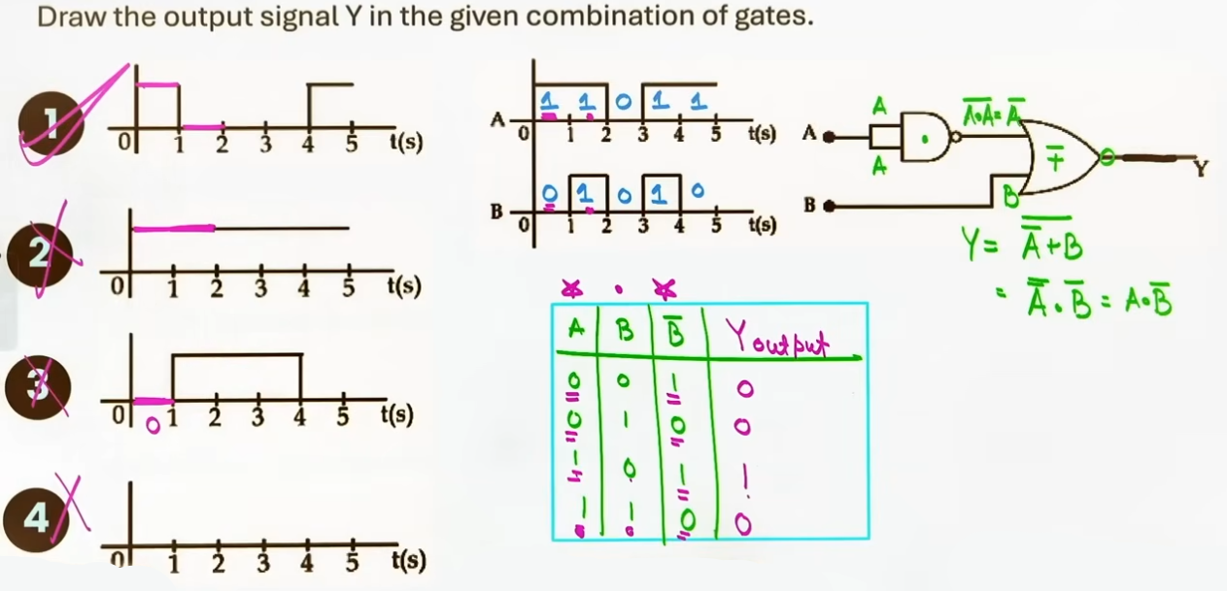

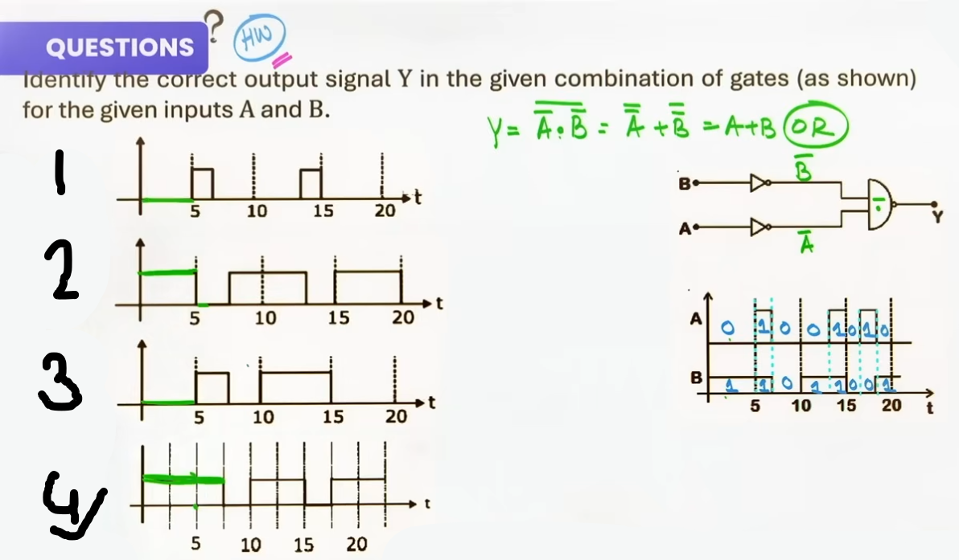

FORMULA SHEET

- Basic Gate Summary Formulas:
OR Gate: Y = A + B
AND Gate: Y = A · B
NOT Gate: Y = A_bar

- Universal Gate Summary Formulas:
NAND Gate: Y = (A · B)_bar
NOR Gate: Y = (A + B)_bar

- Special Gate Summary Formulas:
XOR Gate: Y = A_bar · B + A · B_bar = A ⊕ B
XNOR Gate: Y = A · B + A_bar · B_bar = A ⊙ B

- Boolean Identity Formulas:
A + 0 = A
A + 1 = 1
A + A = A
A · 0 = 0
A · 1 = A
A · A = A
A + A_bar = 1
A · A_bar = 0
A_bar_bar = A

- De Morgan's Theorems:
(A + B)_bar = A_bar · B_bar
(A · B)_bar = A_bar + B_bar

- Number of Input Combinations Formula:
Combinations = 2ⁿ (where n is the number of input terminals).

Gate Classification Comparison Table:
Gate Name | Category | Boolean Expression | Output Y = 1 Condition | Output Y = 0 Condition
OR | Basic | Y = A + B | At least one input is 1 | All inputs are 0
AND | Basic | Y = A · B | All inputs are 1 | At least one input is 0
NOT | Basic | Y = A_bar | Input is 0 | Input is 1
NAND | Universal | Y=(A·B)_bar | At least one input is 0 | All inputs are 1
NOR | Universal | Y=(A+B)_bar | All inputs are 0 | At least one input is 1
XOR | Special | Y = A ⊕ B | Inputs are DIFFERENT | Inputs are IDENTICAL
XNOR | Special | Y = A ⊙ B | Inputs are IDENTICAL | Inputs are DIFFERENT

JEE ADVANCED INSIGHTS

1. Universal Gate Inverter Equivalences:
A single NAND or NOR gate with its inputs connected together acts strictly as a NOT gate.
NAND with tied inputs: Y = (A · A)_bar = A_bar.
NOR with tied inputs: Y = (A + A)_bar = A_bar.

2. XOR and XNOR Complement Relationship:
The complement of an XOR gate is an XNOR gate:
(A ⊕ B)_bar = A ⊙ B.
(A_bar · B + A · B_bar)_bar = A · B + A_bar · B_bar.

